**Mini Project report on**

# POWER GENERATING FLOOR SYSTEM

# Submitted by

## ALAN MATHEW[FIT21EC012]



**Focus on Excellence**

**Department of Electronics & Communication Engineering**

**FEDERAL INSTITUTE OF SCIENCE AND TECHNOLOGY (FISAT) ®**

### Angamaly-683577, Ernakulam

Affiliated to

**APJ ABDUL KALAM TECHNOLOGICAL UNIVERSITY**

Thiruvananthapuram-695016

**MAY 2024**

# Mini project report on

# POWER GENERATING FLOOR SYSTEM

**Submitted by**

## ALAN MATHEW[FIT21EC012]



**Focus on Excellence**

**Department of Electronics & Communication Engineering**

**FEDERAL INSTITUTE OF SCIENCE AND TECHNOLOGY (FISAT)®**

**Angamaly-683577, Ernakulam**

Affiliated to

### APJ ABDUL KALAM TECHNOLOGICAL UNIVERSITY

Thiruvananthapuram-695016

MAY **2024**

### FEDERAL INSTITUTE OF SCIENCE AND TECHNOLOGY (FISAT) ®

Mookkannoor(P.O), Angamaly-683577



**Focus on Excellence**

### CERTIFICATE

This is to certify that the Mini project report titled **Power generating floor system** submitted by **Alan Mathew**, towards partial fulfilment of the requirements for the award of the degree of **Bachelor of Technology** in Electronics and Communication Engineering is a record of bonafide work carried out by them during the academic year 2024.

Project Guide Head of the Department

Internal Examiner External Examiner

Place: Mookkannoor

Date:

## ACKNOWLEDGEMENT

We extend our heartfelt gratitude to all those who have contributed to the completion of this project. Their support, guidance, and encouragement have been invaluable throughout this journey.

First and foremost, we would like to express our deepest appreciation to **Asst.Prof.Christy Jose**, for their continuous support and guidance. Their expertise and insightful feedback have been instrumental in shaping this project and pushing us towards excellence.

We are also immensely thankful to **FISAT** for providing us with the necessary resources, facilities, and infrastructure essential for the successful execution of this project.

Furthermore, we would like to extend our thanks to our fellow classmates and colleagues for their cooperation and assistance during various stages of this project. Their collaboration and constructive discussions have enriched our understanding and helped us overcome many challenges. Our team members for their dedication, hard work and collaboration in bringing the feeder system, contributing their skill and efforts to its successful implementation.

Last but not least, we owe a debt of gratitude to our friends and family for their unwavering encouragement, understanding, and patience throughout this endeavor. Their moral support has been our source of strength during both the highs and lows of this project.

## ABSTRACT

*Our project, a power generating flooring system, utilizes human movement to generate electricity, offering a sustainable solution to energy needs. We are proposing this idea not as an alternative to the conventional sustainable energy sources but as a method which can be implemented along with the preexisting ones .Through the integration of piezoelectric materials embedded beneath the floor surface , the system converts mechanical energy into electrical energy, which is then utilized to power lighting installations. The study explores potential applications in diverse environments, including commercial buildings, public spaces, and transportation hubs. Cost-benefit analyses and environmental assessments highlight the system's economic and ecological advantages compared to traditional energy sources. As part of campus automation, we are planning to integrate such a floor system to the existing infrastructure by installing it in areas like corridors staircase, sidewalks etc.*

## LIST OF FIGURES

**Fig. No. Fig. Name Page No.**

3.1 Flowchart 15

3.2 Circuit Diagram 16

4.1 Piezo sensor 18

4.2 Buck Booster Converter 19

4.3 Arduino Uno 20

4.4 Voltage Sensor 21

5.5 Lcd display 22

## LIST OF TABLES

|  |  |
| --- | --- |
| **Table. No. Table. Name** | **Page No.** |
| 6.1 Cost Of Components | 23 |

**ABBREVIATIONS**

RST : Reset

ICSP : In-circuit serial programming

**CONTENTS**

**PAGE NO**

**Chapter 1 INTRODUCTION 10**

**Chapter 2 LITERATURE SURVEY**

**2.1 STUDY ON FOOTSTEP POWER 11**

**GENERATION USING TILES**

**2.2 ENERGY HARVESTING USING 12**

**PIEZOELECTRICITY**

**2.3 ANALYSIS OF THE 13**

**OF PIEZOSENSORS**

**2.4 PIEZOELECRIC ENERGY 14**

**HARVESTING SOLUTIONS**

**Chapter 3**

**3.1 FLOWCHART 15**

**3.2 CIRCUIT DIAGRAM 16**

**3.3 WORKING 17**

**Chapter 4 COMPONENTS IN DETIALS**

**4.1 PIEZOSENSOR 18**

**4.2 BUCK BOOSTER CONVERTER 19**

**4.3 AURDINO UNO WITH ATMEGA 328 20**

**4.4 VOLTAGE SENSOR 21**

**Chapter 5 LCD DISPLY 22**

**Chapter 6 COST OF COMPONENTS 23**

**Chapter 7 RESULT 24**

**Chapter 8 CONCLUSION 25**

**Chapter 9 REFERENCE 26**

### Chapter 1

### INTRODUCTION

A power generating floor system utilizing footsteps is a revolutionary concept in renewable energy generation. By harnessing the kinetic energy generated by human foot traffic, this innovative technology offers a sustainable solution for powering various applications. As individuals walk across specially designed flooring panels, the pressure exerted by their footsteps is converted into electrical energy through piezoelectric mechanisms embedded within the flooring.

This energy can then be stored or directly used to power lighting, sensors, or other electrical devices, making it a promising solution for high-traffic areas such as malls, airports, and stadiums.

The implementation of power generating floor systems not only provides an eco-friendly source of electricity but also encourages energy awareness and conservation. By visibly demonstrating the link between human activity and energy production, these systems can raise public consciousness about sustainability and promote responsible energy consumption habits.

Moreover, in densely populated urban environments where space for traditional renewable energy installations may be limited, integrating power generating floors into infrastructure offers a space-efficient means of harnessing renewable energy. Overall, this technology represents a significant step towards creating more self-sufficient and environmentally friendly built environments.

**Chapter 2**

### LITERATURE SURVEY

#### 2.1 STUDY ON FOOTSTEP POWER GENERATION USING PIEZOELECTRIC TILE ANIS MAISARAH MOHD ASRY, FARAHIYAH MUSTAFA, SY YI SIM, MAIZUL ISHAK, AZNIZAM MOHAMAD

#### FACULTY OF ENGINEERING TECHNOLOGY, UNIVERSITI TUN HUSSEIN ONN MALAYSIA, MALAYSIA

#### *The non-renewable sources of energy such as fossil fuels are depleting at a rapid rate which creates a need for new ways for power generation*

#### *This can be done with the help of the prospects of energy that is being wasted such as footsteps*

#### *An average human takes about 3000-5000 steps a day. This is being wasted on a daily basis*

#### *The vibration can be converted into electrical energy through electrostatic, electromagnetic and piezoelectricity*

* *There are many companies adapting to the idea of using piezoelectric tiles as their products adapting to their large amount of scope in the industry in the coming scenarios.*

#### 2.2 ENERGY HARVESTING USING PIEZOELECTRICITY

#### RENEWABLE AND SUSTAINABLE ENERGY CONVERSION USING PIEZOELECTRIC TRANSDUCERS BY AKSHAY PATAIL, MAYUR JADEHV, SHREYAS JOSHI

#### *In today’s modern life we depend on machines which in a nonrenewable source of energy.*

#### *As our need increases the nonrenewable source of energy does not increase proportionally.*

#### *We are adopting the idea of producing energy with the help of wasted footsteps.*

#### *Piezo electricity works on the principle of converting stress to electricity*

* *In densely populated urban environments where space for traditional*
* *renewable energy installations may be limited, this creates a huge amount of limitation when we observe in the economical scenario as well as the environment.*
* *The efficiency of piezoelectric energy harvesting depends on factors like material properties, the frequency and magnitude of the mechanical vibrations, and the design of the harvesting system*
* *Integrating power generating floors into infrastructure offers a space-efficient means of harnessing renewable energy.*

#### 2.3 ANALYSIS OF THE CHARACTERISTICS OF PIEZOELECTRIC SENSOR AND

#### RESEARCH OF ITS APPLICATION

#### Li Tianze, Zhang Xia, Jiang Chuan, Hou Luan

#### School of Electric and Electronic Engineering, Shandong University of Technology ,

#### 12 Zhangzhou Road Zibo, 255049, China

#### Piezoelectric ceramics is referred to polycrystal made by maxed oxide (zirconia, lead oxide, Titania, etc.)

#### *In the application of these devices, piezoelectric ceramics must have high power and the characteristics of strain amplitude*

#### *In the operation of strong exchange resonance mode, the oscillator should be possible to meet the deformation, that is to say piezoelectric ceramics have a very high-pressure power factor, not fever, high conversion efficiency, large electromechanical coupling coefficient.*

* *It shows wide frequency response which helps to analyses very low ultrasonic frequencies. This characteristic enables their vibration monitoring, structural health monitoring, and acoustic measurement*
* *Piezo electric sensors can be miniaturized without sacrificing performance, making them suitable for integration into small devices and systems.*

#### 

#### *Thus, these piezo ceramics are used for the production of piezo sensors*

#### 2.4 PIEZOELECTRIC ENERGY HARVESTING SOLUTIONS

#### RENATO CALIÒ 1UDAYA BHASKAR RONGALA 1, DOMENICO CAMBONI 1, MARIO MILAZZO 1CESARE STEFANINI 1 GIANLUCA DE PETRIS AND CALOGERO MARIA ODDO 1

#### *Energy harvesting or energy scavenging is the process of extracting small amount of energy from ambient environment through various sources of energy.*

#### *The available energy for harvesting is mainly provided by ambient light (artificial and natural lighting), ambient radio frequency, thermal sources and mechanical sources.*

#### *Another emerging field of application is biomedical systems, where the energy could be harvested from an off-the-shelf piezoelectric unit and used to implement drug delivery systems or tactile sensors*

* *They are used in various applications, from wearable devices to infrastructure monitoring.*
* *Some solutions include embedding sensors in roads pavements etc. to capture energy from the movement. They are also used in sensors to power small electronic or in industrial setting to harness energy from machine vibrations*

#### *Recent research also includes energy conversion from the occlusal contact during chewing by means of a piezoelectric layer and from heart beats.*

**Chapter 3**

**3.1 FLOWCHART**

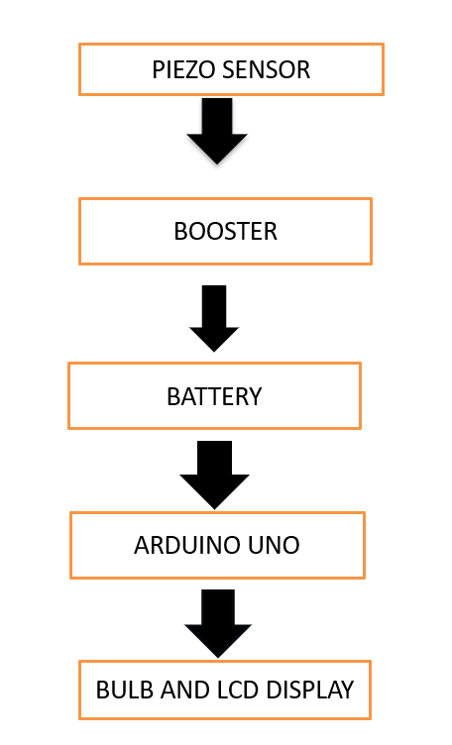

Fig.3.1FLOWCHART

### 3.2 CIRCUIT DIAGRAM

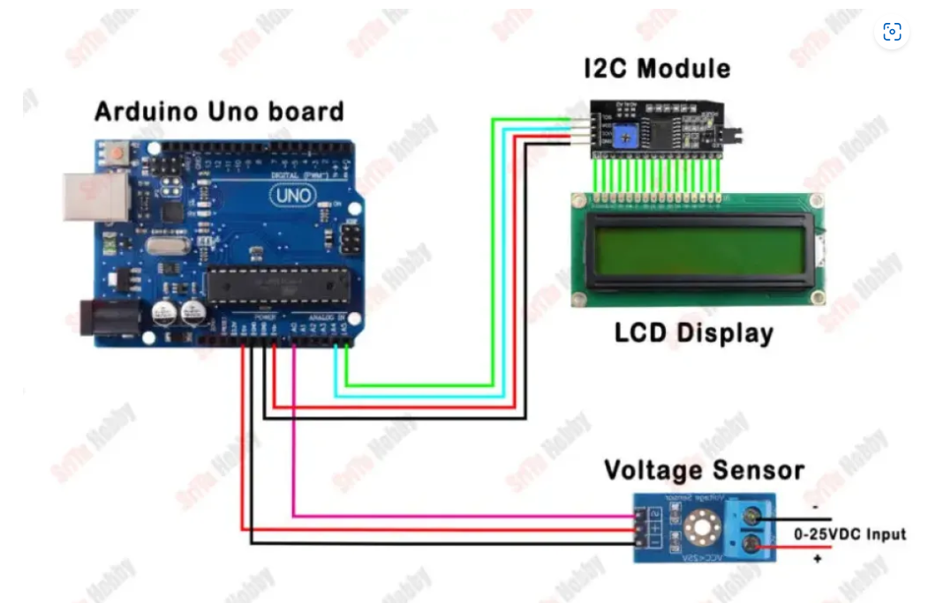

Fig 3.2 Circuit diagram

**3.3 WORKING**

* **CONNECTION OF THE PIEZO SENSORS** : The sensors are connected in series and parallel connections so that the maximum output can be obtained from the sensors. The particular connection allows the obtaining of maximum amount of power.
* **PIEZOSENSORS TO VOLTAGE BOOSTER**: The piezo sensors are connected to buck-boost converter voltage booster which enables DC-DC voltage boosting. It can produce an output voltage that is either higher or lower than the input voltage, making it a versatile power conversion topology for various applications in power electronics where input voltage regulation and output voltage requirements may vary.
* **OUTPUT OF THE VOLTAGE BOOSTER TO STORAGE BATTERY**: The output of the voltage booster is connected to the storage battery and in this case the storing is done with the help of 3 lithium cell.
* **LIGHTING OF BULB**:The output from the battery is connected to the DC bulb with the help of a switch .

**Chapter 4**

**COMPONENTS IN DETAILS**

* 1. PIEZOSENSOR

A Piezo disc element is a type of piezoelectric sensor that converts mechanical stress or pressure into an electrical voltage and vice versa. The "50mm" specification refers to the diameter of the disc element, which is 50mm in this case. Piezo disc elements are commonly used in a wide range of applications, including pressure sensing, actuator, acoustic and vibration sensing, and in ultrasonic transducers. Piezo discs can be used to sense velocity sensitive impact, or can be wired as buzzers. Also, by applying force to the piezo disc, a small voltage can be generated .A piezo disc element is a type of piezoelectric device that is used to generate or detect mechanical vibrations. It consists of a thin, circular disc of piezoelectric material that is able to generate or detect electrical charges when subjected to mechanical stress. Piezo disc elements are often used in a variety of applications that require the detection or generation of mechanical vibrations, such as in ultrasound imaging, force sensing, and acoustic transducers. They are known for their high sensitivity and fast response time, and they are able to operate over a wide range of frequencies.

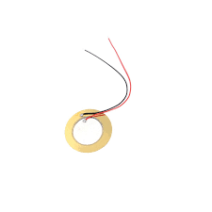

Fig 4.1 35mm piezosensors

* 1. BUCK BOOST CONVERTER

The buck-boost converter is a type of DC-DC converter that can produce an output voltage that is either higher or lower than the input voltage, making it a versatile power conversion topology for various applications in power electronics where input voltage regulation and output voltage requirements may vary. The buck-boost converter operates in two distinct modes: the "buck" mode, where the output voltage is lower than the input voltage, and the "boost" mode, where the output voltage is higher than the input voltage. The transition between these two modes is smooth, enabling the converter to maintain a stable output voltage under varying input conditions. The buck-boost converter operates using a switch, typically a transistor, and a diode, which control current flow through an inductor and a capacitor. During the switch's ON state, energy is stored in the inductor, and during the OFF state, the energy is transferred to the output through the diode. The duty cycle of the switch, or the ratio of ON time to the total period of the switching cycle, determines the converter's output voltage. Adjusting the duty cycle allows the output voltage to be controlled and maintained at the desired level.

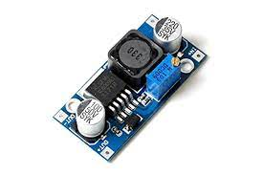

Fig 4.2 XL6009 DC-DC BUCK BOOSTER

* 1. AURDINO UNO WITH Atmega 328

The Arduino Uno is one kind of microcontroller board based on ATmega328, and Uno is an Italian term which means one. Arduino Uno is named for marking the upcoming release of microcontroller board namely Arduino Uno Board 1.0. This board includes digital I/O pins-14, a power jack, analog i/ps-6, ceramic resonator-A16 MHz, a USB connection, an RST button, and an ICSP header. All these can support the microcontroller for further operation by connecting this board to the computer. The power supply of this board can be done with the help of an AC to DC adapter, a USB cable, otherwise a battery.

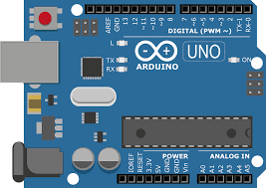

Fig 4.4 Aurdino uno with Atmega 328

4.4 VOLTAGESENSOR

* Voltage sensors are used to measure the voltage level of a power supply or battery. They are commonly used in electronic circuits to monitor voltage levels and trigger alarms or control circuits when voltage levels reach critical levels.
* Using a **0-25V voltage sensor** with Arduino and an OLED display module can help you easily monitor and display voltage levels in real-time.
* A 0-25V voltage sensor is an electronic device designed to measure the voltage level of a direct current (DC) power source.
* The voltage sensor is typically connected to the power source using a pair of wires or leads, and the output of the sensor is usually in the form of an analog voltage or digital signal that corresponds to the input voltage level.

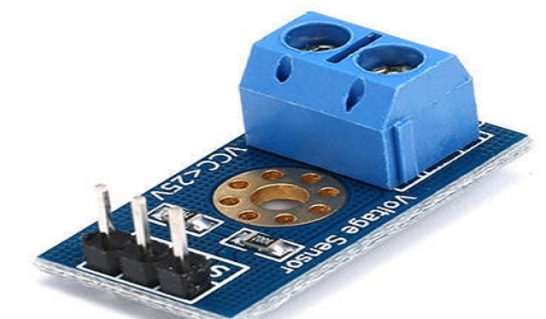

Fig 4.5 Voltage detection sensor module

**Chapter 5**

### LCD DISPLAY

**5.1**  A 12x4 LCD display is a type of liquid crystal display (LCD) that has 12 columns and 4 rows of characters, providing a total of 48 character spaces. Each character space can accommodate a single alphanumeric character or symbol.

The physical size of the display may vary depending on the manufacturer, but it typically accommodates 12 characters per row and 4 rows of characters. The display has a resolution of 12 columns x 4 rows, allowing it to display a total of 48 characters at a time.

A 12x4 LCD display typically interfaces with microcontrollers or other control circuits using parallel or serial communication protocols. Common interfaces include 4-bit or 8-bit parallel interfaces, as well as I2C or SPI serial interfaces.

Similar to other LCD displays, a 12x4 LCD may include features such as backlighting for visibility in low-light conditions, adjustable contrast settings, and various character sets and fonts.

x4 LCD displays are commonly used in applications where a moderate amount of information needs to be displayed, such as consumer electronics, industrial control panels, instrumentation, and more.

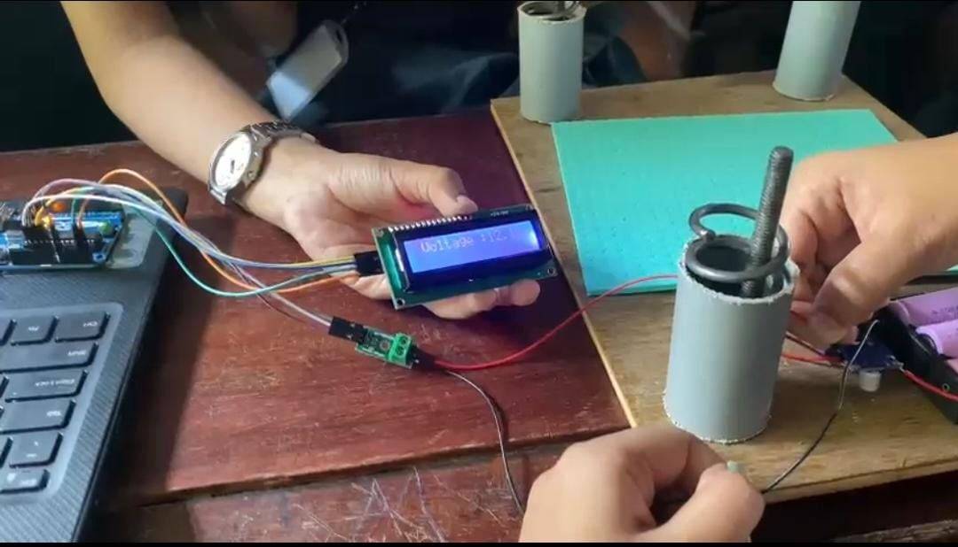

Fig 5.1 LCD Display

**Chapter 6**

**COST OF THE PRODUCTS**

Table 6.1 Cost Estimation

|  |  |  |  |  |
| --- | --- | --- | --- | --- |
| **NAME OF THE**  **COMPONENTS** |  | **QUANTITY** |  | **COST** |
| 35 mm Piezosensors | 40 |  | 400 |  |
| Aurdino uno | 1 |  | 3000 |  |
| Bulb | 1 |  | 110 |  |
| Spring  Type 1  Type 2 | 2  8 |  | 199  299 |  |
| Rectifier | 1 |  | 389 |  |
| Battery | 1 |  | 460 |  |
| Total |  |  | 4857 |  |

TABLE 6.1

**Chapter 7**

**RESULT**

* The heart of this project is the piezoelectric sensors that we use. The placement of the sensors plays an important role since it affects the power generated. The voltage produced by the sensors are connected to the voltage booster so that the output can be amplified .
* Arduino UNO with AT mega 328 is used to analyze the power produced and given as the output through the LCD display.
* The main objective of this project is to use it as a complementary method for sustainable power generation techniques like solar energy. The whole system is placed at places with major foot traffic in order to produce the maximum possible power.
* The LCD Display will allow the user to track the amount of power produced from the signals produced by the Arduino UNO.
* The XL6009 DC- DC Adjustable Step UP Boost Power Converter Module is a buck booster converter that boosts the setup

**Chapter 8**

**APPLICATIONS**

* Energy Harvesting: Piezoelectric flooring can be used to harvest energy from footsteps in high-traffic areas like malls, airports, or train stations. The energy generated can be used to power low-energy devices such as LED lighting, sensors, or small electronic gadgets.
* Health Monitoring: In healthcare facilities or smart homes, piezoelectric flooring can be utilized to monitor the movement patterns and gait of elderly individuals or patients. Changes in gait can provide insights into the individual's health status and potential risks of falls.
* Security and Surveillance: Piezoelectric flooring can be integrated into security systems to detect and alert authorities to unusual movements or intrusions. For example, in sensitive areas like museums or data centers, the flooring can detect unauthorized footsteps and trigger alarms.
* Structural Health Monitoring: In buildings and infrastructure, piezoelectric sensors embedded in flooring can monitor structural integrity by detecting vibrations, stress, and strain. This information can be used for predictive maintenance to prevent catastrophic failures.
* Virtual Reality and Gaming: Piezoelectric flooring can enhance the immersive experience in virtual reality environments and gaming by providing tactile feedback to users. For example, users can feel vibrations or textures corresponding to virtual terrain or actions.
* Traffic Monitoring: In smart cities, piezoelectric flooring installed on roads can monitor traffic flow, vehicle weight, and speed. This data can be used for traffic management, road maintenance planning, and vehicle weight enforcement.
* Environmental Monitoring: Piezoelectric flooring can be deployed in outdoor environments to detect seismic activity, such as earthquakes or landslides. It can also monitor natural phenomena like foot traffic in wildlife reserves to prevent habitat disturbance.
* Sports Performance Analysis: In sports training facilities or stadiums, piezoelectric flooring can analyze athletes' movements and performance metrics such as force exertion, stride length, and foot pressure distribution. This information can help coaches optimize training programs and prevent injuries.
* Human-Computer Interaction: Piezoelectric flooring can be used as an input device for interactive installations or augmented reality applications. Users can control digital interfaces or trigger events by walking or interacting with the sensor-embedded floor.
* Industrial Automation: In manufacturing plants, piezoelectric flooring can detect the movement of machinery, materials, or personnel. This data can be used for process optimization, workflow management, and ensuring safety compliance.

### Chapter 9

### CONCLUSION

In conclusion, the power generating floor system utilizing piezo sensors presents a promising solution for harnessing energy from human movement in various settings. Through the conversion of mechanical stress into electrical energy, this innovative technology offers numerous benefits, including sustainable power generation, reduced environmental impact, and potential applications in high-traffic areas such as public spaces, transportation hubs, and even residential buildings.

Despite its potential, further research and development are essential to optimize efficiency, durability, and cost-effectiveness. Addressing challenges such as sensor sensitivity, material resilience, and system scalability will be critical in realizing the full potential of this technology.

Overall, the power generating floor system represents a significant advancement in renewable energy harvesting, offering a practical means of integrating sustainable power generation into everyday environments while promoting energy efficiency and environmental stewardship. With continued innovation and investment, this technology has the potential to play a pivotal role in shaping the future of energy infrastructure and sustainability initiatives worldwide.

**CHAPTER 10**

### REFERENCE

[1] IEEE “Paper on advanced footstep power generating system”: by Anish Mishra *Mohammad Asry* published on oct 14,2018

[2] IEEE “Paper on piezoelectric energy harvesting system presented by Telecom Italia”, *White lab ,via Cardinal Maffi 27,Italy*

[3] IEEE Paper on design and construction of magneto strictive energy harvester power generating floor system ,paper *presented 18th International Conference ICEMS* , Pattaya , Thailand